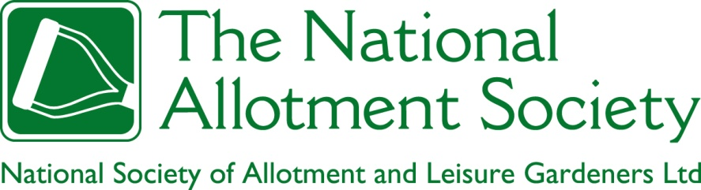

NAS Policy 105. Devolved Management
1. The Society believes that well thought out and well implemented schemes for the devolved management of allotment gardens offer a wide range of benefits to all stakeholders in allotments, including allotment authorities, allotment providers, allotment associations, allotment garden tenants and wider society. The Society therefore welcomes such schemes in principle.

2. The Society also recognises, however, that devolution carries risks, particularly to the allotment associations and allotment stewards accepting responsibility for the management of allotments, but also for the allotment authorities involved, which rely on the continuing capacity of associations and stewards to fulfil their commitments. For this reason, the Society believes that the level of devolution, and the management vehicle proposed for and adopted by individual allotment sites, should be commensurate with the commitment, capacity, and accountability of the associations involved. The Society recognises that it has a duty to its members to ensure that both devolved managers, and the allotment authorities devolving responsibility to them, are adequately appraised of the risks they face and the means available to mitigate those risks, including insurances for third party and employers’ liability. In addition, the Society recognises that it has a duty to advise its members of the risks that may arise from not accepting devolved management when it is offered. Such risks may include the loss of effective services, with a resultant degradation of sites making them more susceptible to closure.
3. Where the level of devolution that appears to be sustainable varies across the allotment sites proposed for devolved management, the Society opposes the imposition of a “one size fits all” policy for devolution, and advocates instead the staged introduction of
devolved management. It will, however, support comprehensive schemes for devolution across allotment portfolios, if variations in the need for management support are properly recognised and addressed, for example through partnership arrangements between larger and smaller sites, or the provision of additional support from the devolving authority.

4. The Society encourages the parties to devolved management to consider the long term advantages of local federations of allotment associations, federations that can offer a collective voice and mobilise a wider pool of financial and material resources, while capitalising on the shared wisdom and experience of federation members. The Society also encourages allotment associations/federations and local authorities to consider the benefits of collaborative working, to make best use of available resources and secure additional support through fundraising.

5. The Society insists that devolved management does not negate the statutory duty of allotment authorities to provide a sufficient number of allotment gardens. For this reason, adequate reporting requirements should be put in place, particularly where responsibility for maintaining waiting lists is devolved to associations, to ensure that an allotment authority has the information required to monitor unmet demand for allotment gardens across its entire area of jurisdiction.

6. The Society insists that local authorities have a duty to monitor devolved management arrangements, and to intervene if devolved managers no longer have the capacity to fulfil their commitments. The Society also recognises the responsibility of allotment associations or federations administering devolved management sites to acknowledge when devolved management is failing, and to take steps to reinstate effective management.

7. The Society recognised that allotment associations and federations of local allotment associations involved in devolved management schemes are the de facto agents of the local authority in delivering management of its allotment portfolio. For this reason, it is the
responsibility of the local authority to ensure that devolved managers have access to such training and material support as may be necessary for them to discharge their duties in accordance with current good practice. Where the local authority does not have the capacity to deliver such training and support, either directly or through its contracted professional development providers, it should seek the advice of the Society on alternative approaches.

8. The Society also recognises the right of devolved managers to the quiet enjoyment of their own allotment gardens at such times as they are not discharging duties defined under the devolved management agreement.

9. The Society believes that the volunteer hours contributed by devolved managers, and by allotment garden tenants acting beyond the terms of their tenancy agreements, should be recognised as a contribution “in kind”, and valued at an appropriate equivalent market rate, for the purposes of grant applications requiring co-funding and submitted in support of allotment site improvement schemes.

10) Given that devolved management can save allotment authorities substantial sums based on the efforts of volunteers, the Society believes it is appropriate that the rents charged to associations for the lease of allotment sites should be set at peppercorn levels.

